**Exercise 6**

**Basic Map**

1) Open **initial file** report in the above folder:

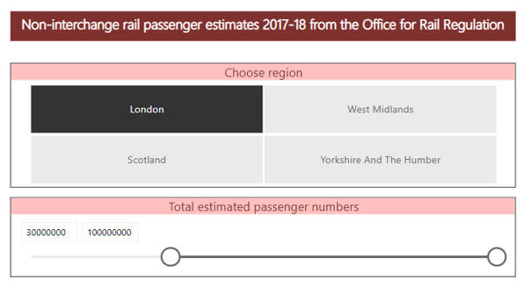

*The report contains data on UK station usage in 2017-18, broken down by ticket type.  The data is genuine!*

Create a map showing the usage of stations for the region and passenger numbers chosen in the slicers:

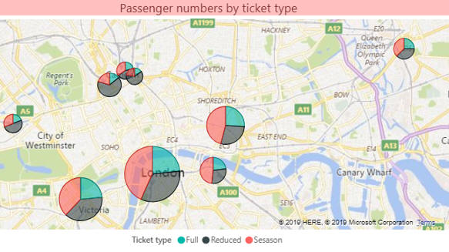

*This is only a suggestion for how your map could look.  Make sure you display the****Passengers****on your chart, not the****Estimated Passengers****one.*

Add a tooltip field so that you can see which station you're looking at:

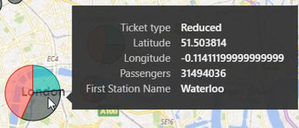

Add a table which shows the data for the pie chart slices you select:

|  |  |
| --- | --- |
| *Slices* | *Table of data* |
|  | *... you should see the season ticket travel for the 3 stations in question.* |

Save this report as **the Big Smoke**, then close it down.

2)Create a new Power BI file, and load data from the **Create-a-creature** database. Load the tables **tblCentre**, **tblFamily**, **tblProduct**, **tblPurchase** and **tblTown**.

Create a map showing the sales by family for each town, but only for shopping centres having at least 100,000 square metre size:

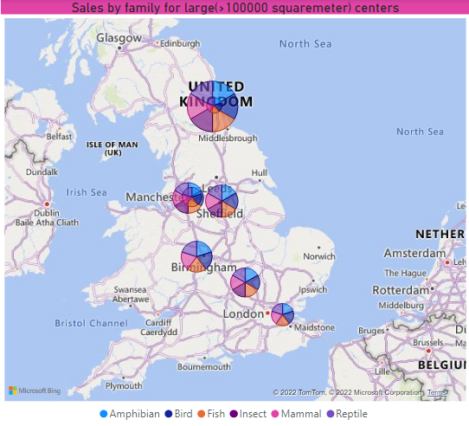

*You'll need to geocode the towns to tell Power BI Desktop they're in the UK, and also increase your bubble size to about 50%.*

 Save this file as **Trivial Pursuits**, and close down this instance of Power BI Desktop.

3) Open **Basic report** report in the above folder:

Create an ArcGIS heat map showing that - as always - London dominates everything:

Remembering to summarize by the **Latitude** and **Longitude** fields (and not average them, as will happen by default) create an ArcGIS heat map showing that - as always - London dominates everything:

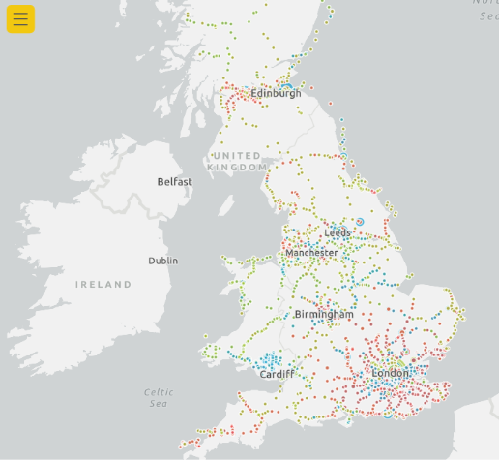

Save this report as **London calling**, then close it down.

4) Create a new Power BI Desktop file, and from **House price data september2016**, load both worksheets in the Excel workbook in the above folder.

In Query Editor, solve this problem:

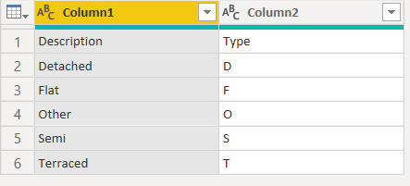

Create a relationship between the two tables:

Now create a slicer allowing you to show only certain types of houses:

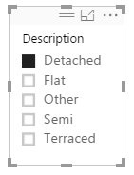

Now create a map showing the number of sales of this house type for our September 2016 data by location:

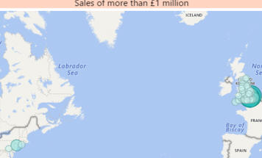

*Things aren't looking good - Power BI Desktop is not recognising that the locations are all in the UK.*

Create an additional column in the main table suffixing **, UK** onto the end of each location, and use this instead in your map:

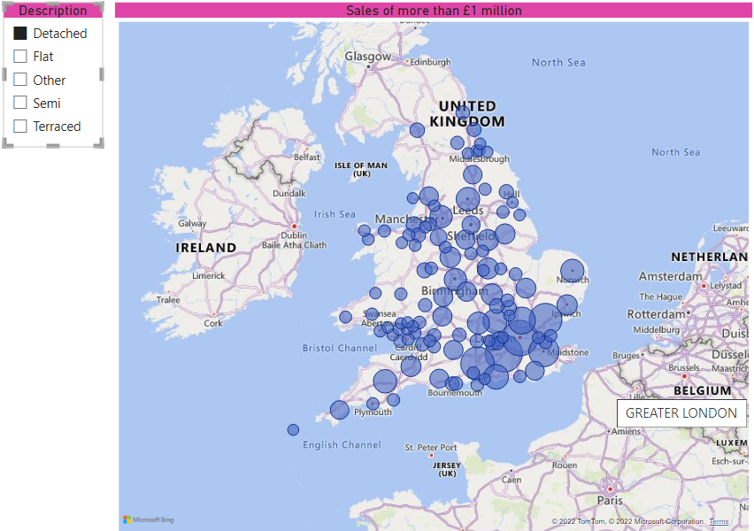

*Much better!*

Save this as **United Kingdom**, then close down the Power BI instance containing it.

5) Create a new Power BI report, and load data from **Construct a creature** workbook in the above folder.

Create a field in the towns table to fix each town firmly within the UK:

*The column should include the name of the country the towns belong to.*

Create a map showing total quantity of sales by this town, using the region to get the colouring shown:

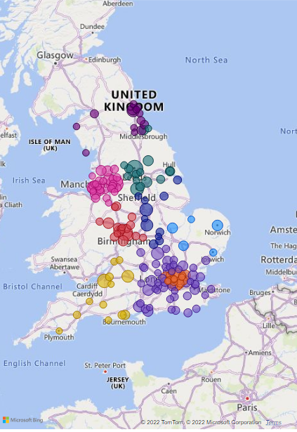

*The map shows different regions in different colours.*

Add a slicer to limit the towns to those in the regions you select:

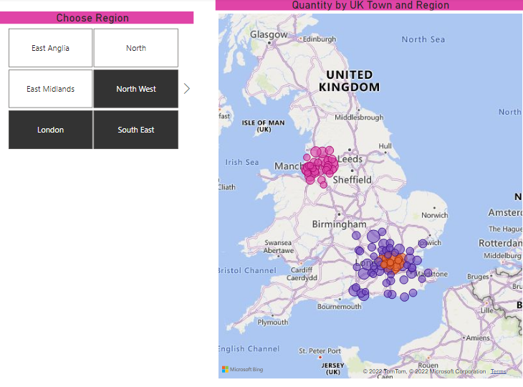

Add another table to show the quantity sold for each shopping centre in any town you click on:

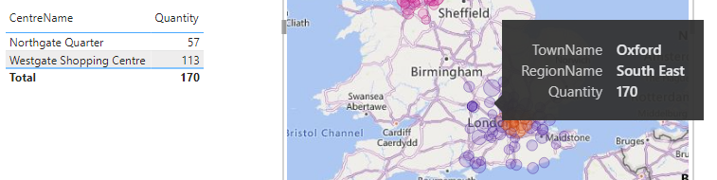

Save your report as **South East Sales**, then close this instance of Power BI down.

6) Create a new Power BI Desktop, Use **Region and Voting** workbook in the above folder .  Remove a few columns in Query Editor, and create a new one showing the percentage leave vote to give:

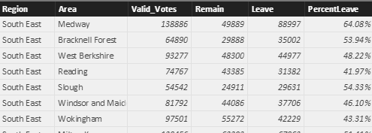

Create a table showing the 10 areas with the highest percentage of votes to leave:

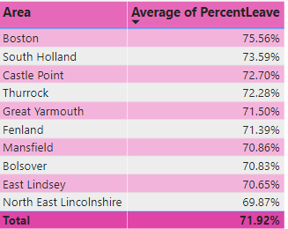

*This hasn't got much to do with maps, but it's fun showing how you can analyse real data so easily!*

 Create as good a map as you can of the percentage leave voters by area:

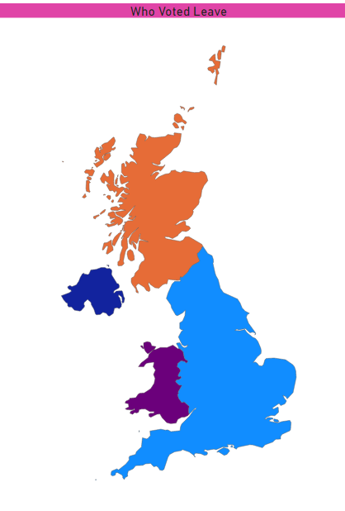

*This included enabling the****Shape Map Visual****in Power BI Desktop options, loading the****Regions****workbook from the above folder to associate each region of the country with England, Wales, Scotland or Northern Ireland, and designating the country column to be of data type****Country****.*

Save this file as ***Voter***, then close down the instance of Power BI Desktop containing it.